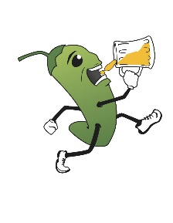
ALAMOGORDO H3 CAMPOUT!!
Event |  | Time | What it is | Hash Provides
Prelube |  | August 26th  6:00 PM | Come get set up early and hang out under the stars! BYOB, but we may have some Kahlua there… | Hot Chocolate  Kahlua
AH3 CAMPOUT  KICKOFF! |  | August 27th  12:00 PM | Lunch, goodie bag handouts, and the opening taping of the keg ceremony (no keg, we just open the cooler) | Subway  Snacks  Goodie Bags  Beer!
AH3 6th Anal  Campout Trail |  | 1:00 PM | A glorious adventure through the magical Apache National Forest. Sperm Whale hares | A hopefully not too shitty trail
Dinner/Circle |  | 4:30 PM | A chance for you to give honors, deal accusations, sing some songs, you know the deal. Lipstick will impress you with his chef skillz! | BBQ, rice and beans, desert  Beer!
HASH O LIMP DICKS! |  | 6:30 PM | Show off your drinking prowess and athleticism. Shiggy in the Shitter presides as head judge and glorious leader | Fabulous prizes  Beer!
Naked Trail!! |  | ZERO DARK THIRTY | You guys wanna go to a rave? I brought glowsticks… Yeast Face Pussy Boogers hares | Beautiful, sculpted bodies  Beer!
Brunch |  | August 28th  9:00 AM | Yeah right you’re gonna be up at 9:00 AM… We’ll have breakfast ready for you whenever you do arise. | Breakfast  Champagne  Bloody Mary’s
Hashers registering early for the AH3 Campout will get a goodie bag with the following!
- Custom Beer Cozy designed just for you!
- T-Shirt
- Commemorative Patch
- Handmade keychain
Rego by July 31st to ensure you get your bag
