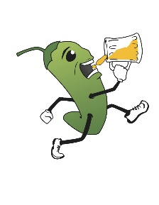
ALAMOGORDO H3 CAMPOUT!!
August 25th thru 27th
Event |  | Time | What it is | Hash Provides
Prelube |  | August 25th  5:00 PM | Come get set up early and hang out under the stars! BYOB. | BYOB / Burgers and Dogs! Maybe a veggie burger or 2 for you vegans…
Sleep In  AH3 CAMPOUT  KICKOFF! |  | 26th August Whenever you get up or get here.  12:00 PM | Wakey, wakey! Eggs and bacon…or whatever we cook up for ya!  Lunch, goodie bag handouts, and the opening taping of the keg ceremony (no keg, we just open the cooler) | Lunch  Goodie Bags  Beer!
AH3 6th Anal  Campout Trail |  | 1:00 PM | A glorious adventure through the magical Lincoln National Forest. | A hopefully not too shitty trail
Dinner/Circle |  | 4:30 PM | A chance for you to give honors, deal accusations, sing some songs, you know the deal. | TBD
HASH O LIMP DICKS! |  | 6:30 PM | Show off your drinking prowess and athleticism. | Fabulous prizes  Beer!
Naked Trail!! |  | ZERO DARK THIRTY | You guys wanna go to a rave? I brought glowsticks… 10 minutes to naked trail!!! | Beautiful, sculpted bodies  Beer!
Brunch |  | August 28th  9:00 AM | Yeah right you’re gonna be up at 9:00 AM… We’ll have breakfast ready for you whenever you do arise. | Whatever’s left

REGO by July 31 to get your gimmies!!!
PATCH
HASH BAG
And maybe a surprise or 2…

